

COMPUTER NETWORKS

EXP 13



October 26, 2021

Roehit ranganathan

RA1911033010017 | L2

# VPN CONFIGURATION

## Aim:

## To implement VPN Configuration using Cisco Packet Tracer.

## Diagram:

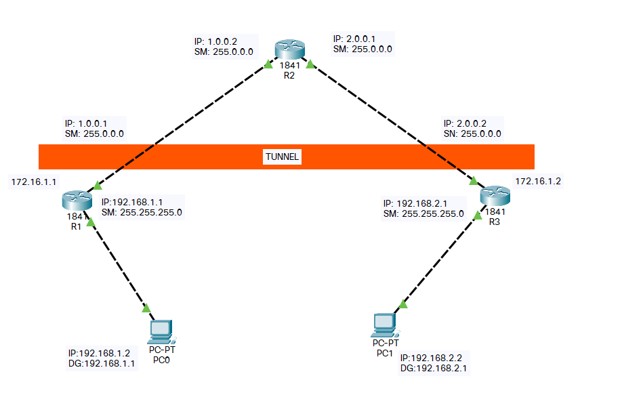

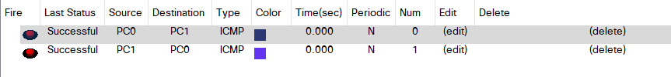

## Procedure:

Create the setup as shown in the following figure and configure everything according to it. After placing the routers, open each one of them, turn the switch off and place WIC-1T in its respective slot and turn the switch back on.

## Configuration on Router R1:

Router>enable

Router#config t

Router(config)#host r1

r1(config)#int fa0/0

r1(config-if)#ip add 192.168.1.1 255.255.255.0

r1(config-if)#no shutdown

r1(config-if)#exit

r1(config)#int fa0/1

r1(config-if)#ip address 1.0.0.1 255.0.0.0

r1(config-if)#no shutdown

## Configuration on Router R2:

Router>enable

Router#config t

Router(config)#host r2

r2(config)#int fa0/0

r2(config-if)#ip add 1.0.0.2 255.0.0.0

r2(config-if)#no shutdown

r2(config-if)#exit

r2(config)#int fa0/1

r2(config-if)#ip add 2.0.0.1 255.0.0.0

r2(config-if)#no shutdown

## Configuration on Router R3:

Router>enable

Router#config t

Router(config)#host r3

r3(config)#int fa0/0

r3(config-if)#ip add 2.0.0.2 255.0.0.0

r3(config-if)#no shutdown

r3(config-if)#exit

r3(config)#int fa0/1

r3(config-if)#ip add 192.168.2.1 255.255.255.0

r3(config-if)#no shutdown

## DEFAULT ROUTING CONFIGURATION ON ROUTER R1:

r1>enable

r1#config t

Enter configuration commands, one per line. End with CNTL/Z.

r1(config)#ip route 0.0.0.0 0.0.0.0 1.0.0.2

r1(config)#

## DEFAULT ROUTING CONFIGURATION ON ROUTER R3:

r3>enable

r3#config t

Enter configuration commands, one per line. End with CNTL/Z.

r3(config)#ip route 0.0.0.0 0.0.0.0 2.0.0.1

r3(config)#

## Testing:

### First, we go to router r1 and ping with router r3:

r1#ping 2.0.0.2

Type escape sequence to abort.

Sending 5, 100-byte ICMP Echos to 2.0.0.2, timeout is 2 seconds:

!!!!!

Success rate is 100 percent (5/5), round-trip min/avg/max = 26/28/33 ms

### Now we go to router r3 and test the network by pinging the router r1 interface.

r3#ping 1.0.0.1

Type escape sequence to abort.

Sending 5, 100-byte ICMP Echos to 1.0.0.1, timeout is 2 seconds:

!!!!!

Success rate is 100 percent (5/5), round-trip min/avg/max = 25/28/32 ms

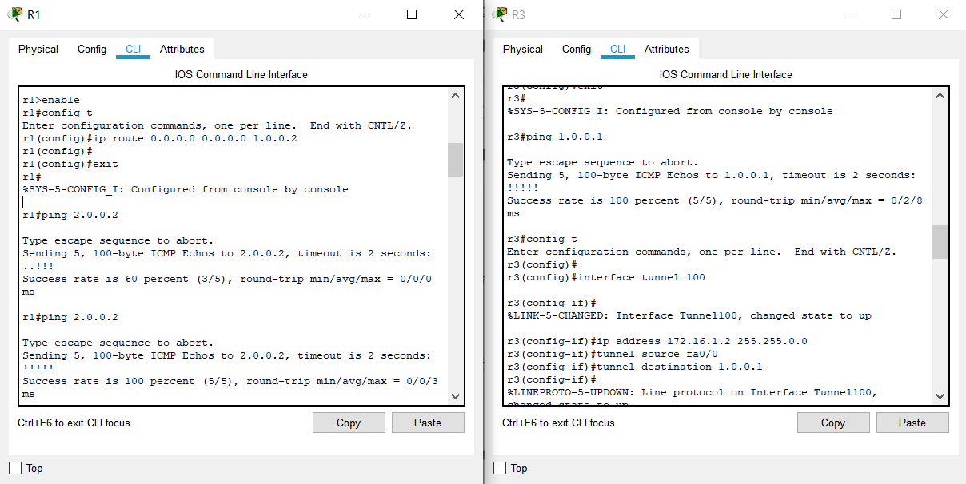

you can clearly see both routers pinging each other successfully.

## NOW CREATE VPN TUNNEL between R1 and R3:

FIRST CREATE A VPN TUNNEL ON ROUTER R3:

r1#config t

r1(config)#interface tunnel 10

r1(config-if)#ip address 172.16.1.1 255.255.0.0

r1(config-if)#tunnel source fa0/1

r1(config-if)#tunnel destination 2.0.0.2

r1(config-if)#no shutdown

### NOW CREATE A VPN TUNNEL ON ROUTER R3:

r3#config t

r3(config)#interface tunnel 100

r3(config-if)#ip address 172.16.1.2 255.255.0.0

r3(config-if)#tunnel source fa0/0

r3(config-if)#tunnel destination 1.0.0.1

r3(config-if)#no shutdown

### Now test communication between these two routers again by pinging each other:

r1#ping 172.16.1.2

Type escape sequence to abort.

Sending 5, 100-byte ICMP Echos to 172.16.1.2, timeout is 2 seconds:

!!!!!

Success rate is 100 percent (5/5), round-trip min/avg/max = 30/32/36 ms

r1#

r3#ping 172.16.1.1

Type escape sequence to abort.

Sending 5, 100-byte ICMP Echos to 172.16.1.1, timeout is 2 seconds:

!!!!!

Success rate is 100 percent (5/5), round-trip min/avg/max = 33/45/83 ms

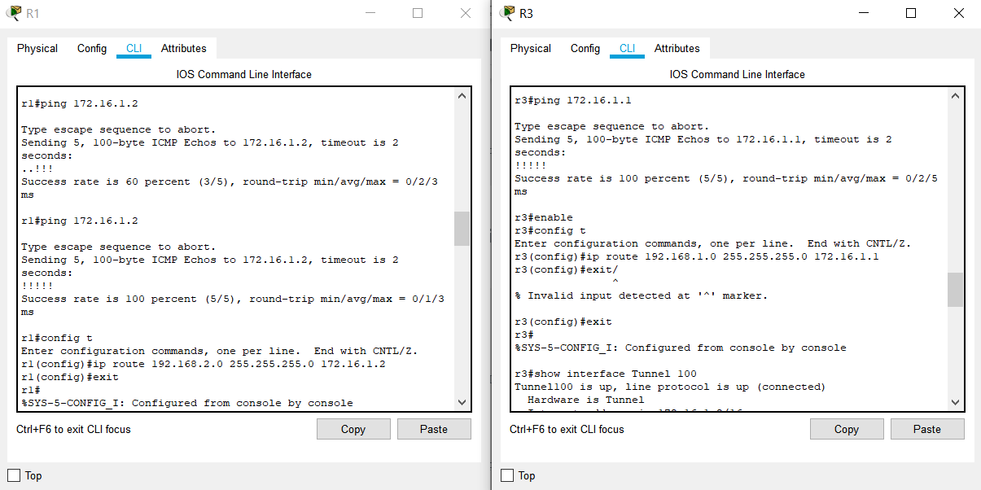

## Now Do routing for created VPN Tunnel on Both Router R1 and R3:

r1(config)#ip route 192.168.2.0 255.255.255.0 172.16.1.2

r3(config)#ip route 192.168.1.0 255.255.255.0 172.16.1.1

## TEST VPN TUNNEL CONFIGURATION:

### Now, I am going to router R1 and test whether tunnel is created or not.

r1#show interfaces Tunnel 10

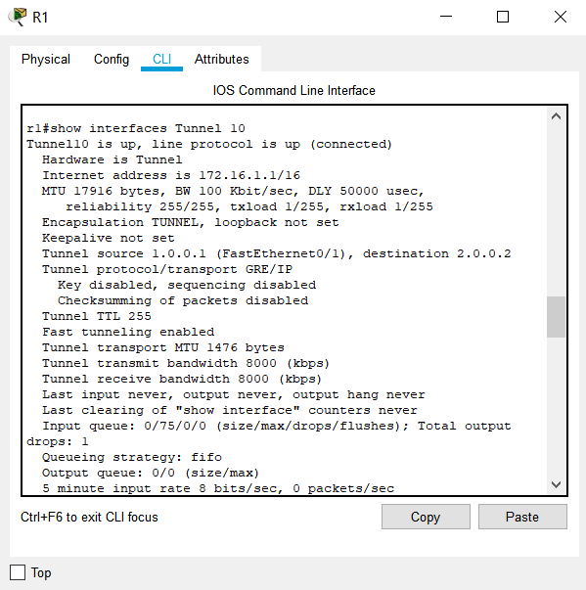

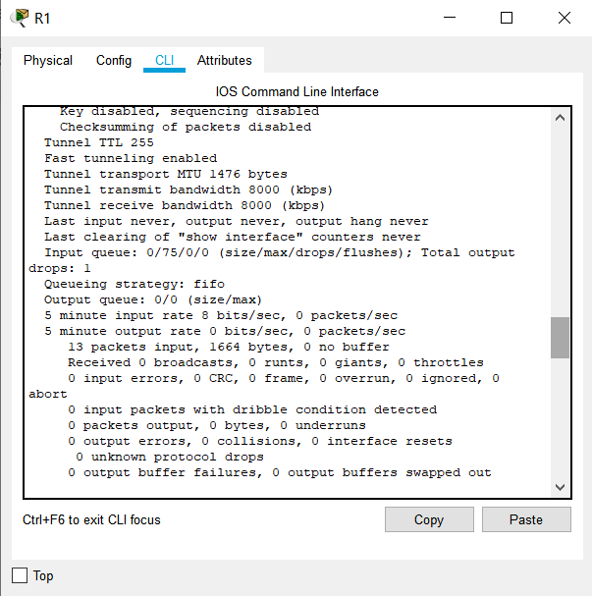

## Now going to Router R3 and test VPN Tunnel Creation:

r3#show interface Tunnel 100

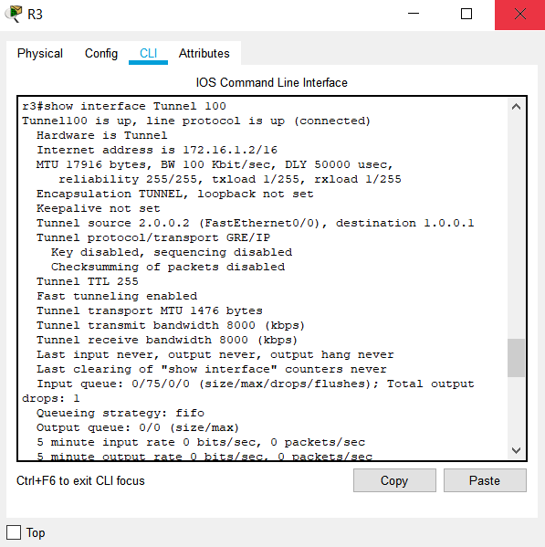

## HOW TO TRACE THE VPN TUNNEL PATH?

### Now if you want to check what path vpn tunnel is using just go to any of the computer i.e pc and then ping another pc located in different network. And then trace the path using tracert. Its result will show the path followed by VPN Tunnel created by you.

PC>ipconfig

PC>ping 192.168.1.2

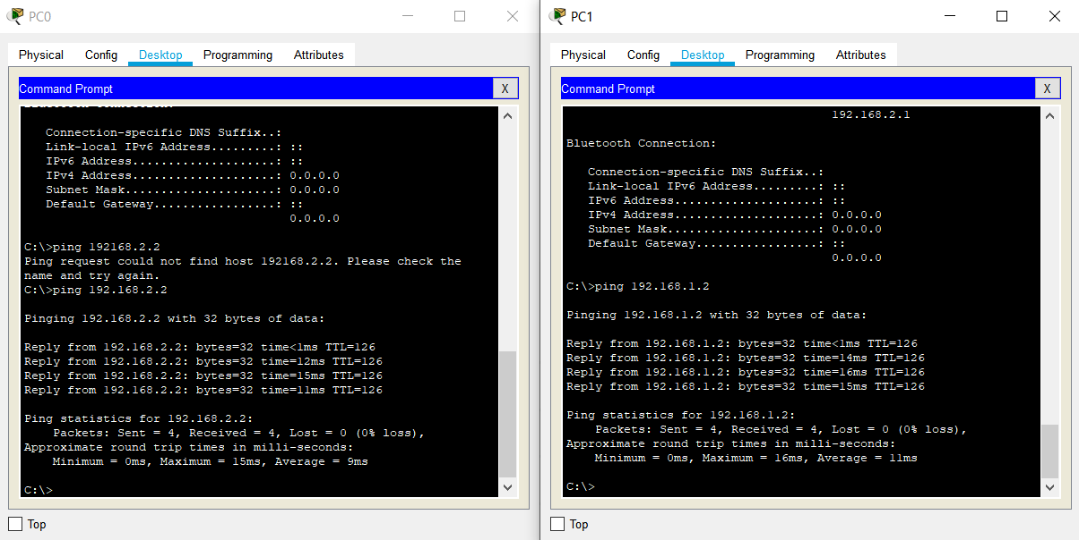

PC>tracert 192.168.1.2

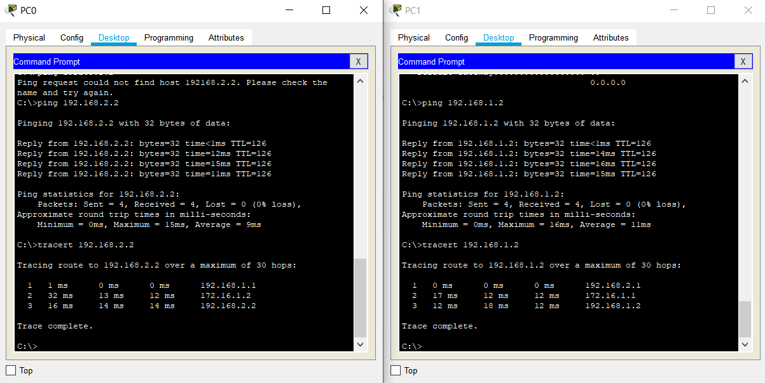

## RESULT:

VPN Configuration is successfully implemented and demonstrated.